DATE:  EXPT NO:01 | SPOTIFY TRACKS SYSTEM USING MACHINE LEARNING

AIM
To analyze earthquake data using Exploratory Data Analysis (EDA), visualize important earthquake patterns, preprocess the dataset, build a Machine Learning model to predict tsunami occurrence, evaluate the model, and export the processed data to Excel.

PROCEDURE
- Download the Earthquake dataset.
- Import the required Python libraries such as Pandas, Matplotlib, Seaborn, and Scikit-learn.
- Load the earthquake dataset using Pandas.
- Display the first few records, dataset shape, information, and missing values.
- Remove unnecessary columns such as title and location columns.
- Check and handle missing or duplicate values.
- Analyze important features such as magnitude, depth, latitude, longitude, cdi, mmi, sig, gap, and nst.
- Visualize the distribution of tsunami occurrences using a count plot.
- Create a visualization to identify the relationship between magnitude and tsunami occurrence.
- Separate the input features (X) and target variable (y), where tsunami is the target.
- Split the dataset into training and testing data.
- Train a Machine Learning model using the training data.
- Predict tsunami occurrence using the test data.
- Evaluate the model using suitable performance metrics such as Accuracy Score and Confusion Matrix.
- Export the processed earthquake data to an Excel file.
- Display the analysis results.
CODE:
import pandas as pd
import matplotlib.pyplot as plt
import seaborn as sns

from sklearn.model_selection import train_test_split
from sklearn.linear_model import LogisticRegression
from sklearn.metrics import accuracy_score, confusion_matrix

# 1. Load dataset
df = pd.read_csv("earthquake_data.csv")

# 2. Display data
print(df.head())

# 3. Basic information
print(df.shape)
print(df.info())

# 4. Check missing values
print(df.isnull().sum())

# 5. Fill missing values
df["cdi"] = df["cdi"].fillna(df["cdi"].median())

df["mmi"] = df["mmi"].fillna(df["mmi"].median())

# 6. Remove unnecessary columns
df = df.drop(["title", "location"], axis=1)

# 7. Visualization - Tsunami
sns.countplot(x="tsunami", data=df)
plt.title("Tsunami Occurrence")
plt.show()

# 8. Visualization - Magnitude vs Tsunami
sns.countplot(x="magnitude", hue="tsunami", data=df)
plt.title("Magnitude vs Tsunami")
plt.xticks(rotation=20)
plt.show()

# 9. Convert categorical data into numbers
df = pd.get_dummies(df, drop_first=True)

# 10. Separate features and target
X = df.drop("tsunami", axis=1)
y = df["tsunami"]

# 11. Split data
X_train, X_test, y_train, y_test = train_test_split(
X, y, test_size=0.2, random_state=42
)

# 12. Train Logistic Regression model
model = LogisticRegression(max_iter=1000)
model.fit(X_train, y_train)

# 13. Make prediction
y_pred = model.predict(X_test)

# 14. Calculate accuracy
accuracy = accuracy_score(y_test, y_pred)
print("Accuracy:", accuracy)

# 15. Confusion Matrix
cm = confusion_matrix(y_test, y_pred)

sns.heatmap(cm, annot=True, fmt="d")
plt.title("Confusion Matrix")
plt.xlabel("Predicted")
plt.ylabel("Actual")
plt.show()

# 16. Export DataFrame to Excel
df.to_excel("earthquake_analysis.xlsx", index=False)

OUTPUT:

title magnitude date_time \
0 M 7.0 - 18 km SW of Malango, Solomon Islands 7.0 22-11-2022 02:03
1 M 6.9 - 204 km SW of Bengkulu, Indonesia 6.9 18-11-2022 13:37
2 M 7.0 - 7.0 12-11-2022 07:09
3 M 7.3 - 205 km ESE of Neiafu, Tonga 7.3 11-11-2022 10:48
4 M 6.6 - 6.6 09-11-2022 10:14

cdi mmi alert tsunami sig net nst dmin gap magType depth \
0 8 7 green 1 768 us 117 0.509 17.0 mww 14.000
1 4 4 green 0 735 us 99 2.229 34.0 mww 25.000
2 3 3 green 1 755 us 147 3.125 18.0 mww 579.000
3 5 5 green 1 833 us 149 1.865 21.0 mww 37.000
4 0 2 green 1 670 us 131 4.998 27.0 mww 624.464

latitude longitude location continent country
0 -9.7963 159.596 Malango, Solomon Islands Oceania Solomon Islands
1 -4.9559 100.738 Bengkulu, Indonesia NaN NaN
2 -20.0508 -178.346 NaN Oceania Fiji
3 -19.2918 -172.129 Neiafu, Tonga NaN NaN
4 -25.5948 178.278 NaN NaN NaN
(782, 19)
<class 'pandas.core.frame.DataFrame'>
RangeIndex: 782 entries, 0 to 781
Data columns (total 19 columns):
# Column Non-Null Count Dtype
--- ------ -------------- -----
0 title 782 non-null object
1 magnitude 782 non-null float64
2 date_time 782 non-null object
3 cdi 782 non-null int64
4 mmi 782 non-null int64
5 alert 415 non-null object
6 tsunami 782 non-null int64
7 sig 782 non-null int64
8 net 782 non-null object
9 nst 782 non-null int64
10 dmin 782 non-null float64
11 gap 782 non-null float64
12 magType 782 non-null object
13 depth 782 non-null float64
14 latitude 782 non-null float64
15 longitude 782 non-null float64
16 location 777 non-null object
17 continent 206 non-null object
18 country 484 non-null object
dtypes: float64(6), int64(5), object(8)
memory usage: 116.2+ KB
None
title 0
magnitude 0
date_time 0
cdi 0
mmi 0
alert 367
tsunami 0
sig 0
net 0
nst 0
dmin 0
gap 0
magType 0
depth 0
latitude 0
longitude 0
location 5
continent 576
country 298
dtype: int64
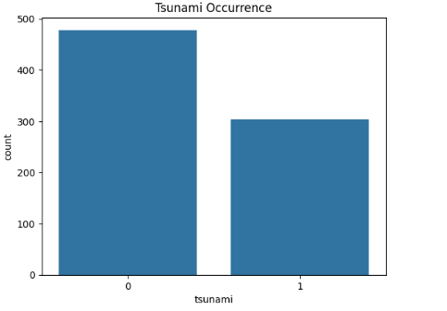
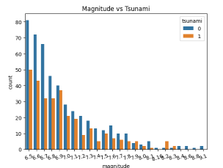
/usr/local/lib/python3.13/dist-packages/sklearn/linear_model/_logistic.py:465: ConvergenceWarning: lbfgs failed to converge (status=1):
STOP: TOTAL NO. OF ITERATIONS REACHED LIMIT.

Increase the number of iterations (max_iter) or scale the data as shown in:
https://scikit-learn.org/stable/modules/preprocessing.html
Please also refer to the documentation for alternative solver options:
https://scikit-learn.org/stable/modules/linear_model.html#logistic-regression
n_iter_i = _check_optimize_result(
Accuracy: 0.8726114649681529

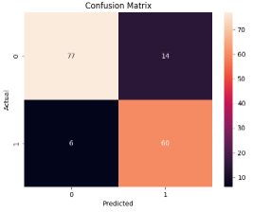

RESULT:
The customer churn dataset was successfully imported, analyzed, visualized, and processed. A Logistic Regression model was trained to predict customer churn, and the model performance was evaluated using accuracy and a confusion matrix. The processed data was also exported to an Excel file.

